6 April 2007 The Weekly Bulletin of Rotary Club of Kathmandu Mid-Town Bc # 40 of 2006-07
Rotary Club of Kathmandu Mid-Town
Breakfast Chatter




District : 3290 Web: www.rotarymidtown.org.np Club Id : 26776

APRIL IS THE MAGAZINE MONTH
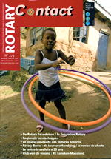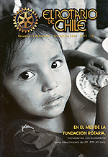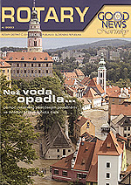
More than half of the Rotarians worldwide are served by Rotary magazines produced independently by Rotarians. They are distributed in 133 countries, published in 22 languages, and have a combined total circulation of 715,000.

Club Secretary Rabi Karmacharya provided an interesting talk on "One Laptop per Child Nepal project"
at the Club meeting on 30 March 2007 as the Inhouse Speaker
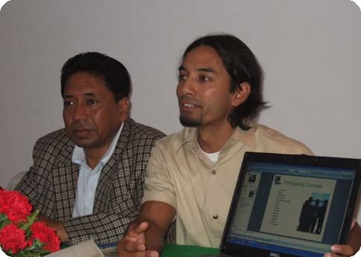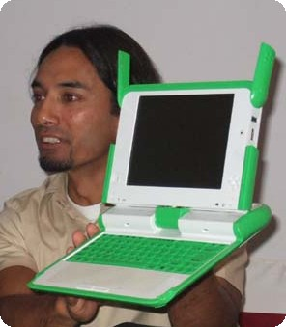
Inhouse Speaker Rabi presenting his talk with the help of his Laptop
while acting President Subarna Joshi looks on.
Rtn Rabi demonstrating 100 Dollar Laptop, which he called rather a 'Learning Tool'.

Weekly Meetings and Programs :
Date | Program/Speaker | Program/Topics of Presentation
6 April 2007 | Dr Lynn Bennett | Social Exclusion in Nepal
13 April 2007 | No meeting | Happy New Year 2064 holiday
20 April 2007 | Club assembly | Club assembly (5)
27 April 2007 | Mangal Man Shakya

Friday, 6 April :
Dr Lynn Bennett, Lead Anthropologist, World Bank Nepal Country Office, will be talking on social exclusion as it applies in Nepal. Her first five years of research among Hindu women in Nepal helped her to produce a book entitled Dangerous Wives and Sacred Sisters – which is now being used as a key text for Women’s Studies by universities in Nepal.

India: orphanages to raise unwanted baby girls :
The Indian government plans to set up a series of orphanages to raise unwanted baby girls in a bid to halt the wide-spread practice of aborting female foetuses. The plan is an attempt to slow the practice that international groups say has killed more than 10 million female foetuses in the last two decades, leading to an alarming imbalance in the ratio between males and females in India. Renuka Chowdhury, the minister of state for women and child development says: What we are saying to the people is have your children, don't kill them. And if you don't want a girl child, leave her to us. We will bring up the children. But don't kill them because there really is a crisis situation. In Indian society girls are seen as a burden on the family, requiring a huge dowry which many poor families can ill afford. They are generally the last to be educated or to get medical treatment. The cradle centers would provide an opportunity for parents who had a change of heart to reclaim their children.
Source: The Himalayan Times

On Lighter Side : Click at the figure ⇩


Literacy has rightly been high on Rotary’s service agenda for many years now, and it should feature among the projects of every Rotary club. Whether the goal is donating books, running literacy classes, supplying elementary school students with dictionaries, or just helping children with their schoolwork, literacy projects bring great results with very little investment of money.
RI President William B. Boyd

6 April 2007 The Weekly Bulletin of Rotary Club of Kathmandu Mid-Town Bc # 40 of 2006-07

Editor: RR Shrestha, Club Service Director email: rryes@wlink.com.np

